Running Head: GETTING DIGITALLY HEALTHY 1

EDLD 5316: Digital Citizenship
Getting Digitally Healthy
Madeline Brandi Collins
Lamar University

GETTING DIGITALLY HEALTHY 2
Today, with the rapid advances in technology, the concept of digital citizenship is continuously being redefined. Most tech savvy people feel they understand what being a good digital citizen entails believing a common sense approach to using the Internet is all they need to be safe. While this approach is all well and good, digital citizenship is a much larger umbrella covering a plethora of topics related to much more than just safety.
In order to comprehend what is under the digital citizenship umbrella, it is helpful to identify some key definitions. Dictionary.com defines citizenship as the state of being vested with the rights, privileges and duties of an individual viewed as a member of society. Dictionary.com also defines a digital citizen in the exact same way.
Clearly, when comparing and contrasting the two, there is no contrast. However, in comparison, it helps to understand the ways in which technology is being utilized in today's society. It has been said that just because kids know how to use social media, it does not mean they know how to use technology to enhance their learning.
This statement correlates nicely to the often asked question, is there a difference between citizenship and digital citizenship? Today, most kids are fortunate enough to be raised by an adult who is generally invested in developing a child with good character. Even children who lack this commitment from a parent can fill this void with the guidance of another family member, teacher or community member.
Children grow up knowing the six pillars of character, but do they always know how to apply them to enhance their learning? So, is there a difference between citizenship and digital citizenship? Most would argue no with the biggest difference coming in knowing how to filter massive amounts of digital info to make the correct choices in applying that knowledge to the
GETTING DIGITALLY HEALTHY 3
real world.
Anyone who uses technology is considered a digital citizen and is responsible for their own sense of character and commitment as a member of an online community. Kappa Delta Pi member, Jason Ohler confirms this point in his article, Digital Citizenship Means Character Education for the Digital Age. Ohler states, the digital age beckons a new era of character education, aimed directly at addressing the opportunities and challenges of living a digital lifestyle (Ohler, 2011).
Taking the article into consideration, digital citizenship can easily be interpreted and redefined as a commitment to effectively applying positive character traits to actions within a highly functioning digital community.
In developing an understanding of digital citizenship and its implementation impact on school districts worldwide, it is essential to identify the Nine Elements of Digital Citizenship:
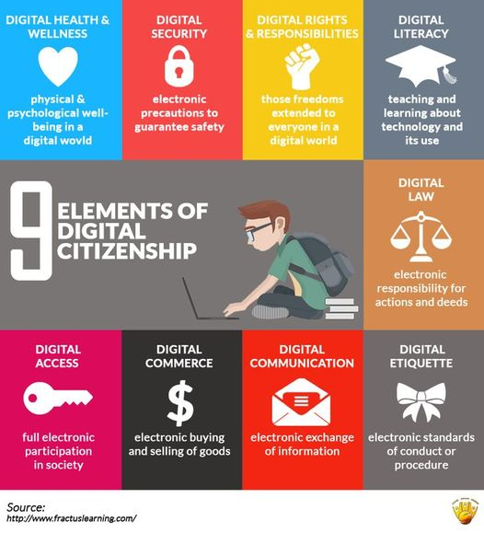
GETTING DIGITALLY HEALTHY 4
Each of the nine elements of digital citizenship are interdependent on one another. With so many intersecting ideas, school districts can easily become tangled and trapped in the massive web of technology do's and don'ts. To avoid the complex nature of navigating digital citizenship, the elements are further broken down into three relatable principles: Respect, Educate and Protect.
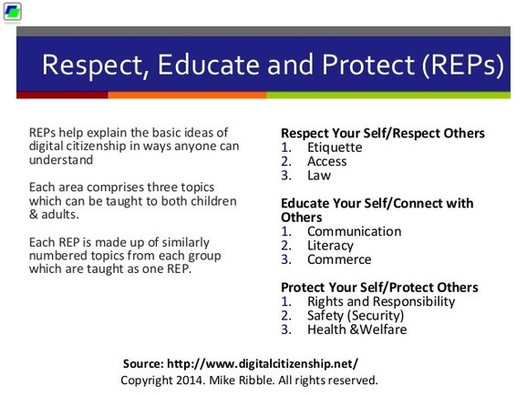
With the REP's, understanding the nine elements of digital citizenship are as easy as 1, 2, 3. All you need to do is to grasp the three definitions of Respect, Educate and Protect and the three elements housed under each category. Then, you are well on your way to becoming a valuable member of the digital community.
It is no secret that school districts worldwide are filled with students who have grown up in a rapidly advancing tech-filled world. Because of this, these students are considered to be digital natives. Given the current state of global connectivity, it is necessary to reiterate and caution
GETTING DIGITALLY HEALTHY 5
educators that just because kids know how to use social media, it does not mean they know how to use technology to enhance their learning. It is equally important for schools to realize that simply hanging a few digital citizenship themed posters in the classrooms and in the hallways is not enough to call yourself a digital citizen. Schools must be aware that authentic digital citizenship learning happens when all stakeholders appropriately acquire the knowledge and effectively apply it to the real world.
The push to integrate technology into most districts is leading more campuses to include digital literacy learning into their diverse curriculums. It is hard to believe that the iPhone 7 is the worst technology today’s five year olds will ever see in their lifetimes. The fast pace of technology use is forcing schools to quickly catch up to the needs of digital native learners by re-designing curriculums around the processes of learning in a digital society. It is imperative that today’s scholars be taught the skills to filter the massive amounts of digital information and the proper ways to use this digital literacy knowledge to their best advantage. ​
To help scholars develop a healthy online presence, schools need to rethink their “two lives” approach to technology use. Ohler describes this “two lives” approach as schools enforcing the rule that once students enter the school building they are made to unplug from technology and when the school day is over, students are free to plug back in as soon as they are off school grounds (Ohler, 2011). This approach sends a negative message to digital natives by insinuating they are not trust-worthy or socially responsible enough to properly use technology within the parameters of the school day.
By encouraging students to live two separate technology lives, schools ae missing out on extremely relevant and necessary opportunities to connect all learning to the real world. With
GETTING DIGITALLY HEALTHY 6
these missed opportunities, Ohler asserts that children are left to fend for themselves as they come to grips with issues of digital citizenship, cyber safety and the responsible use of technology (Ohler, 2011). Since digital native students spend a majority of their day within the confines of the school campus, educators have the most access to influence proper technology use. Schools with zero tolerance technology policies are expending tons of energy and resources fighting battles they are sure to lose.
In these battles, digital natives are going to find a way to incorporate technology into their lives because it is all they have ever known. So as teachers, why not help students find their digital balance by educating them on their rights and responsibilities as digital citizens, encouraging them to always put their best digital foot forward and empowering them with a sense of pride as a valuable member of a global community.
Be that as it may, does the responsibility to educate students on digital citizenship fall solely on the shoulders of schools? Ohler seems to think it does not and claims that involving parents and the community in the character education of our youths only helps to foster stronger digital communities (Ohler, 2011). Ohler believes it is important for students and adults to engage in those crucial conversations about living digitally (Ohler, 2011). Such conversations would allow for all stakeholders to make informed choices about their learning along with the ability to effectively use their voice as a catalyst for change within their respective communities.
When it comes to understanding the various aspects of digital citizenship, equipping all stakeholders with a choice, ownership and a voice in their learning is the best prescription for everyone to achieve the highest levels of digital health.

GETTING DIGITALLY HEALTHY 7
References
Citizenship. (n.d.). Retrieved March 28, 2017, from http://www.dictionary.com/browse/citizenship?s=t
Digital citizen. (n.d.). Retrieved March 28, 2017, from http://www.dictionary.com/browse/digital-citizen?s=t
Gegan, W. (2017, January 25). 9 Elements of Digital Citizenship - Printable Poster. Retrieved March 28, 2017, from https://www.fractuslearning.com/2014/09/09/digital-citizenship-poster/
Nine Elements REP's Graphic. (n.d.). Retrieved March 28, 2017, from http://www.digitalcitizenship.net/Nine_Elements.html
Ohler, J. (2011). Digital citizenship means character education for the digital age. Kappa Delta Pi Record, 47(sup1), 25-27.

